# Day 1_Selenium_Introduction_Installation_Overview

# Introduction to Selenium

## What is Selenium?

Selenium is a free (open source) automated testing suite for web applications across different browsers and platforms. It is quite similar to HP Quick Test Pro (QTP now UFT) only that Selenium focuses on automating web-based applications. Testing done using Selenium tool is usually referred as Selenium Testing.

Selenium is not just a single tool but a suite of software's, each catering to different testing needs of an organization. **It has four components.**

* Selenium Integrated Development Environment (IDE)
* Selenium Remote Control (RC)
* WebDriver
* Selenium Grid

[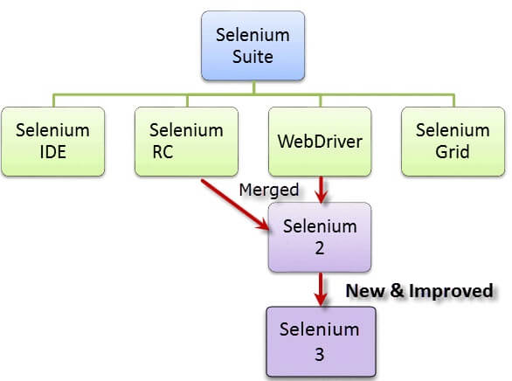](https://cdn.guru99.com/images/SeleniumSuite.png)

At the moment, Selenium RC and WebDriver are merged into a single framework to form **Selenium 2**. Selenium 1, by the way, refers to Selenium RC.

## Who developed Selenium?

Since Selenium is a collection of different tools, it had different developers as well. Below are the key persons who made notable contributions to the Selenium Project

|  |  |
| --- | --- |
| [Introduction to Selenium](https://cdn.guru99.com/images/JasonHuggins.jpg) | Primarily, Selenium was **created by Jason Huggins in 2004**. An engineer at ThoughtWorks, he was working on a web application that required frequent testing. Having realized that the repetitious [Manual Testing](https://www.guru99.com/manual-testing.html) of their application was becoming more and more inefficient, he created a[JavaScript](https://www.guru99.com/interactive-javascript-tutorials.html)program that would automatically control the browser's actions. He named this program as the "**JavaScriptTestRunner**."  Seeing potential in this idea to help automate other web applications, he made JavaScriptRunner open-source which was later re-named as **Selenium Core**. |

## The Same Origin Policy Issue

**Same Origin policy prohibits JavaScript code from accessing elements from a domain that is different from where it was launched**. Example, the HTML code in www.google.com uses a JavaScript program "randomScript.js". The same origin policy will only allow randomScript.js to access pages within google.com such as google.com/mail, google.com/login, or google.com/signup. However, it cannot access pages from different sites such as yahoo.com/search or guru99.com because they belong to different domains.

[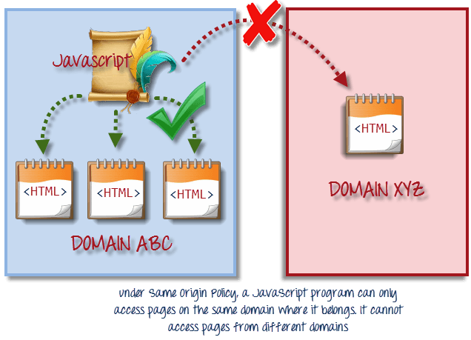](https://cdn.guru99.com/images/same_origin_policy.png)

This is the reason why prior to Selenium RC, testers needed to install local copies of both Selenium Core (a JavaScript program) and the web server containing the web application being tested so they would belong to the same domain